**Testing Task**

1. I used the exploratory testing approach for this project. I logically broke down the flows into various sessions such as:  
   - Registration  
   - Login  
   -Traverse  
   -Vote  
   -Logout

I time boxed testing each session for up to 15 minutes for the flows as I wanted to do rapid testing.

I have created a mind map (please find the image in the github link) which covers all the factors that should be considered to test this project. However, I have focused only on the feature testing aspect for of this assignment, as this is a time boxed activity.

1. Bugs
2. Issue: While logging in I can see my password in the browser’s network tab > Headers > Form Data

Steps to reproduce:

1. On the main page enter your username and password
2. Press F12, go to the network tab & select preserve logs before logging into the application
3. Click the login button and check the very first login request that is created
4. Go to the Headers > Form Data section at the at the bottom of the page

Actual Result:

Able to see the password entered in decrypted format (View Screenshot).  
 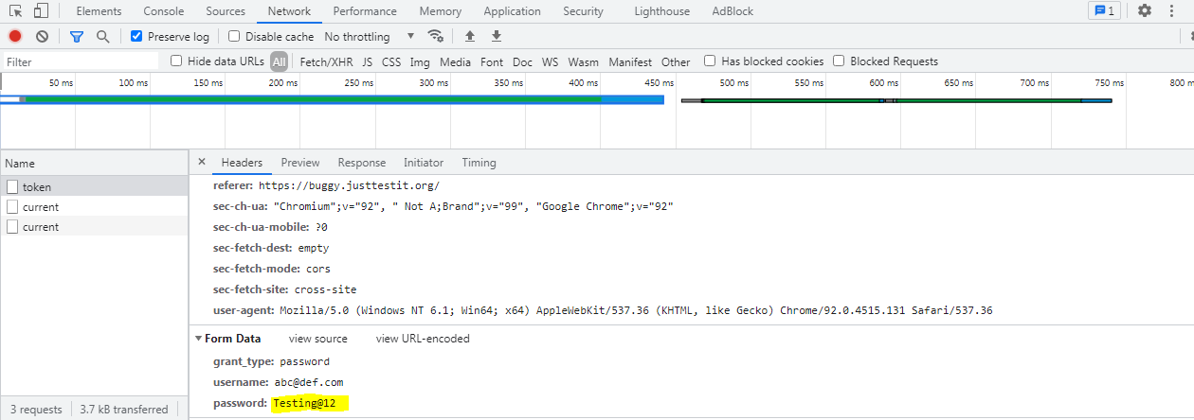

Expected Result:

Expect sensitive data like password to be encrypted to make the application secure.

1. All users comments can be read even after voting and logging out of the application

Steps to reproduce:

1. Login to application
2. Traverse to the voting page by clicking on the car image
3. Cast your vote
4. Logout of the application & scroll down on the page

Actual Result:

Able to view all the user votes as user session is getting cached (View screenshots)  
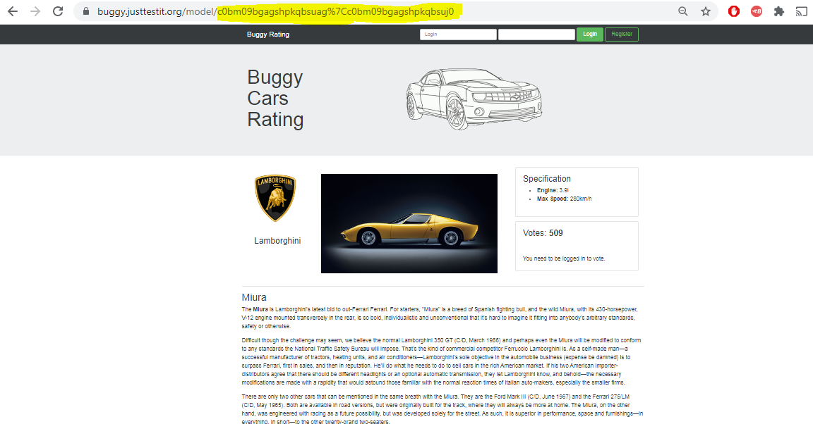

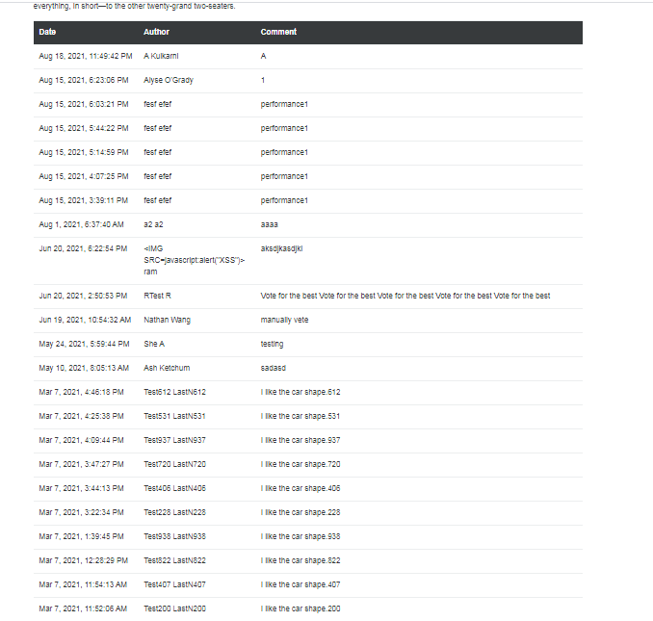

Expected Result:

Expect the session to not store the session cookies and not allow anyone to view user comments after logging out.

1. Unable to use the website until it is refreshed after clicking on the Buggy Rating Title

Steps to Reproduce:

1. Login to the application
2. Cast a vote
3. Go to the 5th page of the application
4. Click on the image of the car named Lancia
5. Click on the Buggy Ratings title

Actual Result:

Clicking on the Profile title or buggy ratings title does not redirect the page anywhere.

Expected Result:

Clicking on the Buggy Rating title should redirect the page to the Main page

1. Application passes null after entering text in the text field for the Lancia car.

Pre-requsites:

The user should not have voted for the Lancia car on the 5th page.

Steps to Reproduce:

1. Login to the application
2. Traverse to the 5th page
3. Click on the image of Lancia car
4. Press F12 and go to the Network tab
5. Click Headers and View Request Payload
6. Add a comment and click Vote

Actual Result:

The comment appears as **null** and the Vote button does not disappear.

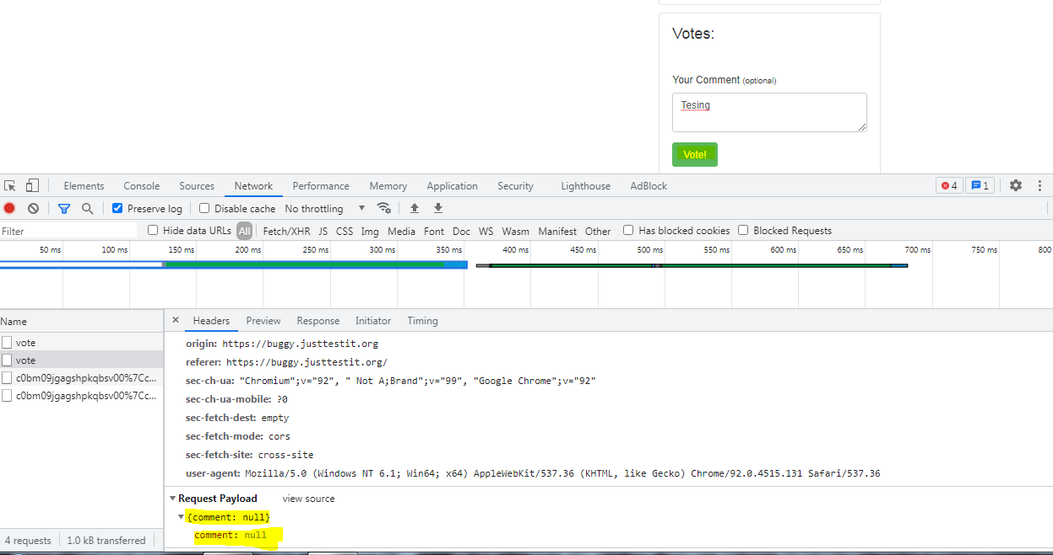

Expected Result:

The field should pass the actual comments & Vote button should disappear.

Follow up tests:

I tried comparing this behavior with other voting modules in the application. On other pages, I was able to vote successfully and the button too disappeared displaying the thank you message.

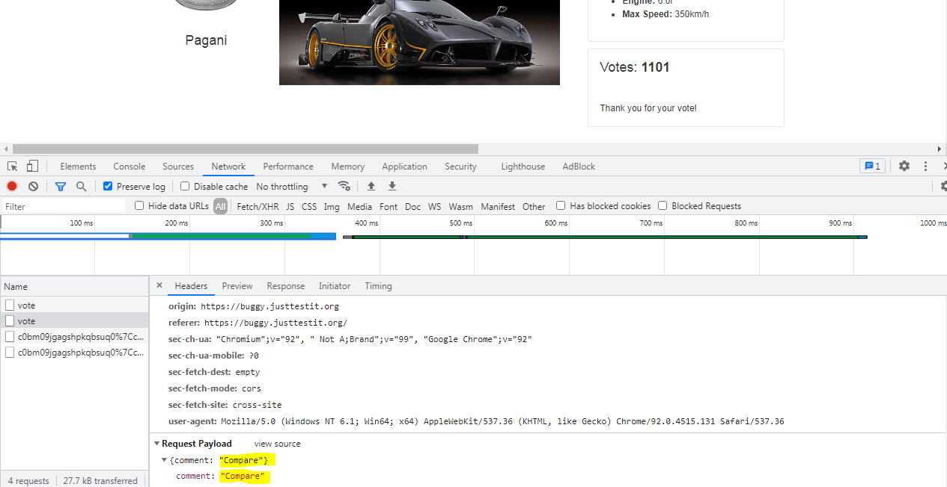

Comments:

I would not consider this to be a critical bug but is surely a major functional issue as it does not record the user’s comments and the vote button is not working as expected.

1. The 5 critical functionalities for this project are:

- Registration  
- Login  
-Traverse  
-Vote  
-Logout

Please refer to the solution on Github to view details.